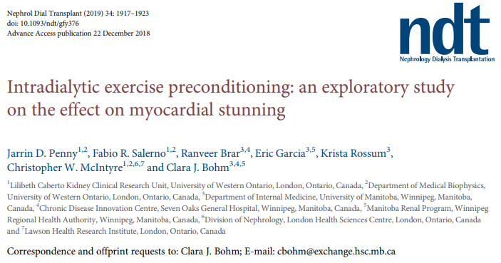
Link to study article: https://academic.oup.com/ndt/article-abstract/34/11/1917/5258055
Study rationale
Cardiovascular disease has been well documented as the leading cause of death in the general population worldwide. In people with end stage kidney disease, the risk of cardiovascular disease is substantially increased. During hemodialysis (HD) in particular, the recurrence of cumulative circulatory stress (myocardial stunning) caused by the treatment further increases the risk of cardiovascular morbidity and mortality.
In the general population, physical activity is known to reduce the incidence of cardiovascular disease by 42-44%, reduce mortality, and hospital admissions. A growing body of literature has supported physical activity during hemodialysis as a safe, low-cost option to improve health related quality of life, physical function, symptom management, as well as improve oxygenation, aerobic capacity, dialysis efficacy, and reduce arterial stiffness.
Ischemic preconditioning, which is the application of small repetitive ischemic insults, improves the ability of the heart to cope with larger ischemic insults such as acute myocardial infarction. Exercise acutely provides cardioprotective effects similar to those described with ischemic preconditioning. This protection occurs immediately and persists for several days. However, the effect of intradialytic exercise on myocardial stunning has previously not been studied.

The current study
The objective of this current study was to assess the effect of intradialytic cycling on myocardial stunning in hemodialysis.
Methods
This was a single-center, cross-sectional study. Participants were drawn from a prevalent adult, in-center hemodialysis program in Manitoba, Canada. All participants were already enrolled in an existing intradialytic exercise program, and regularly participated in the program 1-3 times per week. Table 1 presents the inclusion criteria for the program. Moderate intensity exercise is prescribed in this program, and participants cycle in the first half of their session for 30-60 minutes. No change in the delivery of the exercise program was made as part of the study protocol for this current study.
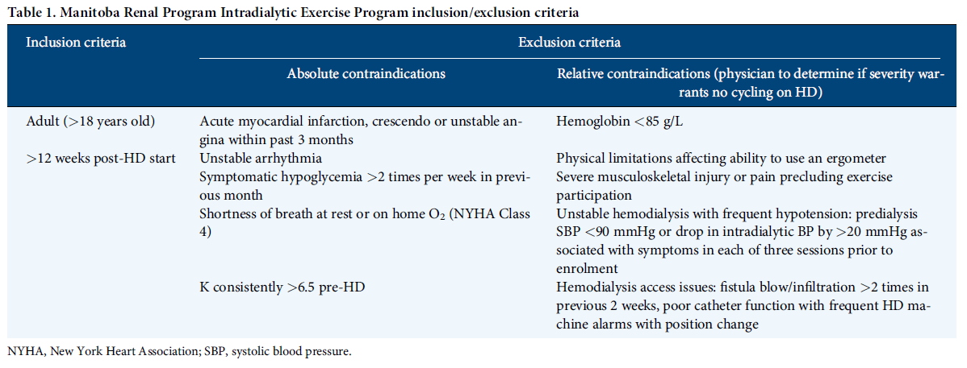
From the 51 eligible patients, 24 participated in the study, and 19 were included in the final analyses. Sample size calculations had indicated that a sample size of 10 participants would be sufficient to detect a difference of at least 20% in the number of effected segments, at a significance level of 0.05 and 80%.
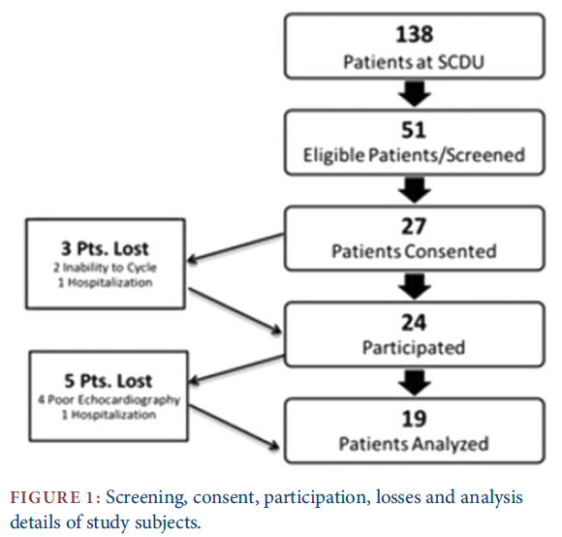
Participant’s hemodialysis treatment information in presented in Table 2, and baseline demographic and clinical information are presented in Table 3.
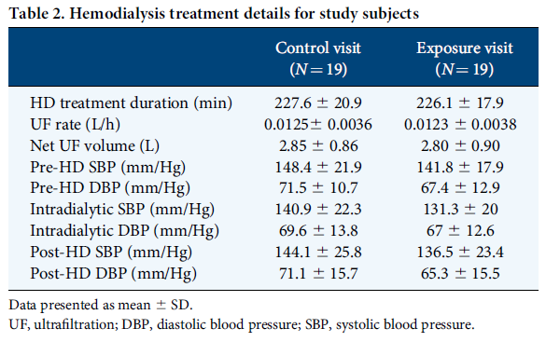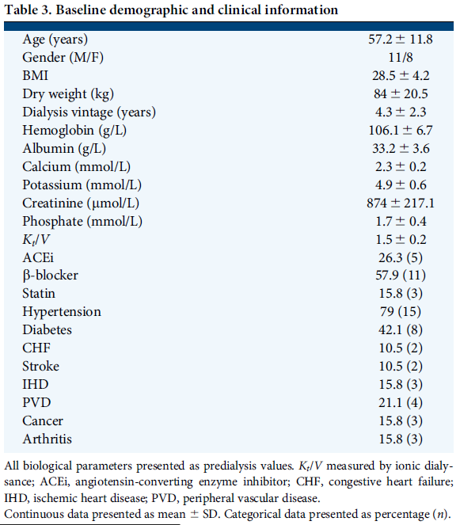
Study Groups:
Each study participant had 2 study visits over the same week:
- The control visit: An HD session with no exercise
- The exposure visit: An HD session during which patients participated in their usual IDE regime.
Outcomes:
The primary outcome was the change in the number of Regional Wall Motion Abnormalities (RWMAs) from baseline to post-exercise, and from baseline to peak HD stress, measured using echocardiograms. Secondary outcomes included the number of episodes of intradialytic hypotension (20mmHg ↓ from start of HD treatment), global longitudinal strain, and left ventricular ejection fraction.
During each visit, 3 echocardiograms were acquired at:
- 15 minutes before start of HD
- Post exercise, and at this same timepoint in the control visit
  - Mean of 77.6 ± 36.6 minutes (range 38-155) into treatment
- Peak HD stress – 15 minutes prior to the each of each HD treatment
  - Mean of 206.4 ± 20.2 minutes (range 185-260) into treatment
Definition of HD-induced cardiac stunning and strain analysis
Segmental values of left ventricular longitudinal myocardial strain were analyzed and reported. Longitudinal Strain is the fractional change in the length of a myocardial segment (12 in total). The values obtained for baseline to post-exercise, & baseline to peak stress were calculated for each segment, as well as globally (average of all segments). If a segment underwent a ≥ 20% reduction in longitudinal strain, then it was considered to have an RWMA and was subject to HD-induced cardiac injury. The presence of myocardial stunning was defined as the clinically significant presence of ≥2 segments with RWMAs.

Results: Exercise & myocardial stunning
In the control visit: 17/19 patients had evidence of myocardial stunning with a cumulative total of 86 segments with RWMAs, with a mean 4.5 ± 2.6 segments (range 2–10) per individual post-exercise. The number of RWMAs increased to 110 in 18 patients, with a mean 5.86 ± 2.7 segments (range 2–12) per individual at peak HD stress.

When patients were exposed to exercise: 14/19 patients developed myocardial stunning at post-exercise, with a total of 68 stunned segments and a mean 3.6 ± 2.7 segments (range 2–10) per individual. At peak HD stress, 18/19 patients were stunned, totaling 76 segments with RWMAs, with a mean 4.0 ± 1.8 segments (range 2–8) per individual.
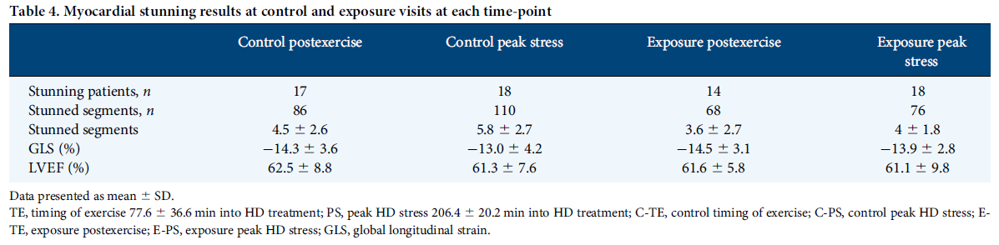
The mean change in the number of RWMAs between control and exposure study visits at post-exercise was -0.95 ± 2.9 (P=0.17). At peak HD stress, the mean difference in the number of RWMAs was -1.86 ± 2.8 (P=0.01).
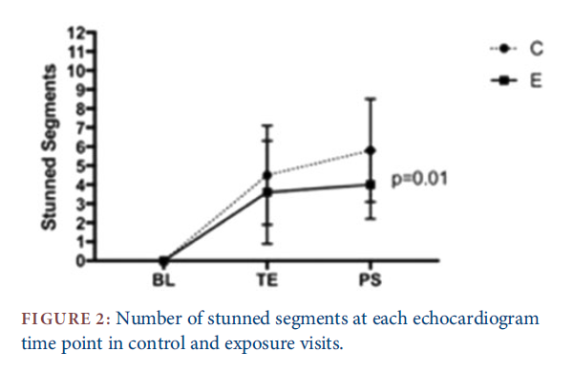
All blood pressure measurements were similar at both visits, and no significant differences were found in the degree of stunning related to the dose of exercise. Lastly, no significant difference was found in the overall global longitudinal strain, nor in the change in left ventricular ejection fraction.
Discussion and Conclusions
In this exploratory study, intradialytic exercise significantly reduced HD-induced myocardial stunning in people receiving maintenance in-center hemodialysis, compared to the standard of care. The cardioprotective nature of intradialytic exercise had the greatest effect at reducing RWMAs at the peak of hemodialysis stress (15 minutes before HD end), which is the timing of dialysis associated with repetitive and cumulative cardiovascular injury, and the highest risk of mortality. The intradialytic exercise also appeared to be safe, with no changes in intradialytic hypotension (a measure of hemodynamic stability).

In a recent study (McGuire et al. (2019). Cardiac stunning during hemodialysis: The therapeutic effect of intra-dialytic exercise. Clinical Kidney Journal.), a cohort of 20 exercise-naïve chronic hemodialysis patients underwent an echocardiography and maximal cardiopulmonary exercise testing. Findings were similar: compared to HD alone, HD + intradialytic exercise reduced cardiac stunning, and global cardiac function, intra-dialytic hemodynamics and left ventricular volumetric parameters were significantly unchanged with exercise.

The findings from this study add to the literature showing exercise during dialysis is both safe, and has cardiovascular benefits. Given that the hemodialysis population has high prevalence rates of cardiovascular morbidity and mortality, intradialytic exercise presents itself as a low-cost, viable therapy with the great potential to improve the physical functioning and wellbeing of patients. Further studies are warranted to determine the impact of intradialytic exercise on the reduction of cardiovascular injury in HD.

Summary prepared by Oksana Harasemiw, GREX Project Manager. The study’s senior author Dr. Clara Bohm edited, reviewed and approved the final version.

